Lift Operations

## Water Lift Pump

**Category:** Lift Operations

**Tags:** PTO Operated lift operational implement

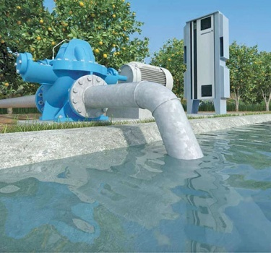

## Description

The agricultural water lift pump is the most effective equipment for irrigation purposes. It has an essential role in agriculture as they pump water from source to the field. It also used to increase the flow of water in ridges or canals.

|  |  |
| --- | --- |
| Specifications | |
| Delivery & Suction Pipe | 8'' - 12'' |
| Pipe Length | 30 Ft |
| Operation | PTO Operated |
| Power Requirement: | 50 - 75 HP |